

assignment 1

Human resource management



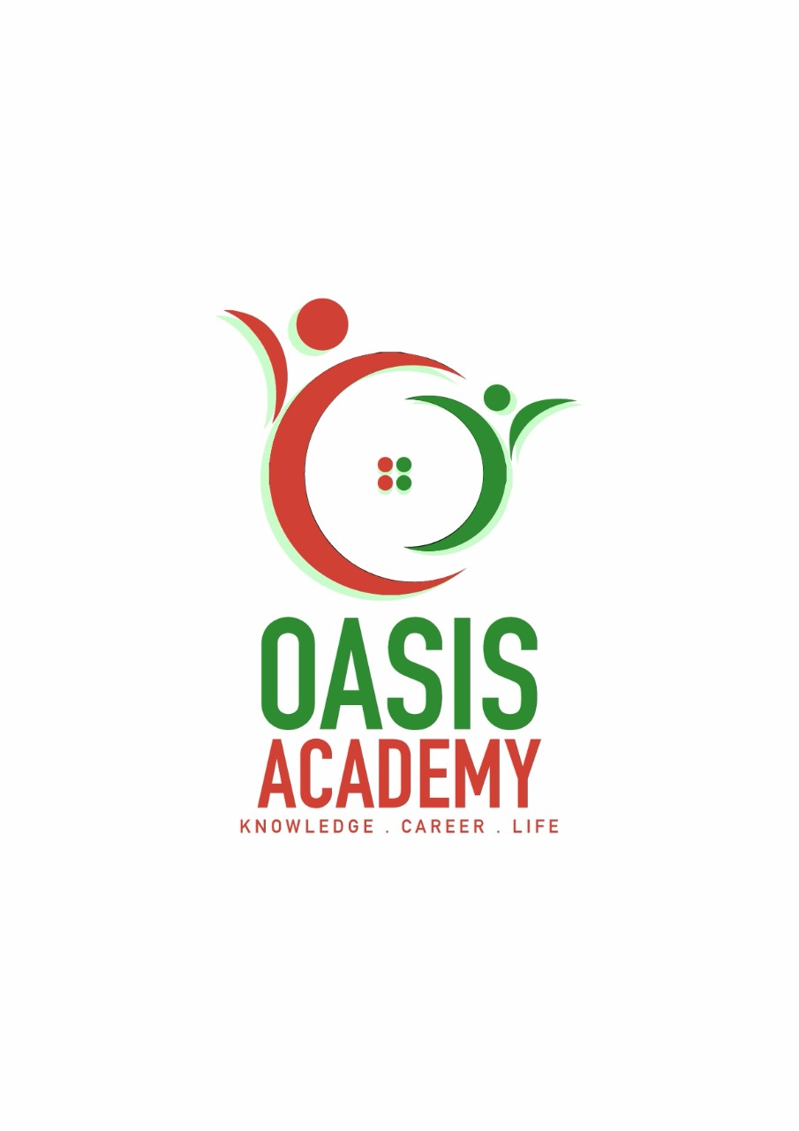

Name: RUBAN KUMAR A/L JEGANATHAN

Login ID: ruban@oasis-portal.com

Course title: Executive Diploma in Business and Hospitality Management

Subject Code: BMH01

**Table of Contents**

|  |  |  |
| --- | --- | --- |
| No | Details | Page |
| 1 | Assignment Question | 2 |
| 2 | Assignment Question | 4 |
| 3 | Assignment Question | 6 |
| 4 | Assignment Question | 8 |
|  | References | 9 |

**Function of Human Resource management.**

A human resources head is responsible for areas of Recruiting. HR need to ensure that they hire the right employee. In order to hire an employee a HR manger has to go through several different steps in the hiring process.

A Human resource head task start from reviewing candidate application. Application review means reading each application received to determine whether the candidate fulfils the requirement and possess the skills, experience or qualification needed for the job.

Once the review is done the human resource head separates those candidate into whom will be interviewed and who will be retained which is called the recruiting process. During the recruiting process the candidate will be interviewed and the most suitable candidate will be selected. An Interviews is the meeting with the candidate to evaluate whether the candidate has the right qualification, skill, experience and attitude for the job. The face to face interview will tell the HR head more about the candidate.

Once the interview sessions is over with the shortlisted candidate, a HR Head is responsible to select the best candidate. HR manager selects the best candidate based on pre-determined list of qualification or criteria necessary to perform the job. Usually the candidate selection is done by the HR head with the help of department heads. Once the right candidate is selected and confirmed HR head is responsible to do background check and reference check are necessary.

Once the selection of best candidate is done, HR Head is responsible to provide the necessary training to the selected candidate. HR head is responsible in making the new employee feel welcome to the new work environment. In this case HR head is responsible to provide necessary information to the new employee such as company policies, presenting organisational chart, discussing departments function, goals, objectives and culture. Explaining inter-relationship of department with other departments. Describing main functions and responsibilities of other members in department. HR head is also responsible introduce the new employee to other members of immediate staff and other key departments. During the first day of employment the employee will be briefed process or procedure related to the business and assign a first project to the employee.

During the working days of the new employee in the company a HR head is required to provide necessary motivation or education to the candidate to improve them self. Employees require high motivation to perform their skills and abilities. This is carried out by the HR head by checking if the employee received all necessary training for his or her position, meeting with employee regularly to discuss any issues or concerns. By giving the necessary motivation an employee will be always stay motivated and inspired.

HR manager is responsible to make sure that all employees are performing well at all time. This is done by performing and evaluation on the employee. Employee evaluation is an important tool for business and benefits the employer and employee. HR department plays a critical role in ensuring that evaluation are done effectively and the information gained is used to aid in employee development as well as in HR processes including recruitment and training.

**Human Resource Planning**

Human resources planning is a process that identifies current and future human resources needs for an organization to achieve its goals.

The strategic HR planning process has four steps:

* Assessing the current HR capacity
* Supply forecasting
* Demand forecasting
* Matching demand and supply
* Action plan human resource planning in hotel industry

Assessing current HR capacity

Based on the organization's strategic plan, the first step in the strategic HR planning process is to assess the current HR capacity of the organization. The knowledge, skills and abilities of your current staff need to be identified. This can be done by developing a skills inventory for each employee.

Supply forecasting

The next step is to forecast HR needs for the future based on the strategic goals of the organization. Realistic forecasting of human resources involves estimating both demand and supply. Questions to be answered include:

How many staff will be required to achieve the strategic goals of the organization?

* What jobs will need to be filled?
* What skill sets will people need?

Demand and supply Forecasting

The next step is to determine the gap between where your organization wants to be in the future and where you are now. The gap analysis includes identifying the number of staff and the skills and abilities required in the future in comparison to the current situation. You should also look at all your organization's HR management practices to identify practices that could be improved or new practices needed to support the organization's capacity to move forward. Questions to be answered include:

* What new jobs will we need?
* What new skills will be required?
* Do our present employees have the required skills?
* Are employees currently in positions that use their strengths?
* Do we have enough managers/supervisors?
* Are current HR management practices adequate for future needs?

Action Plan Human Resources planning in hotel industries

here are five HR strategies for meeting your organization's needs in the future:

* Restructuring strategies
* Training and development strategies
* Recruitment strategies
* Outsourcing strategies
* Collaboration strategies

**Human Resource Policies**

Human resource head is responsible in ensuring all employee adhere to Hotel Human resource policies. For example, the management team must make sure **Professional Image and Grooming Standards** are maintained by employee at all time to portray a professional image and show respect for guests, it is important that team members project a conservative business like appearance in both behaviour and dress. Personal Hygiene is required by all team members, such as daily bathing, shaving, use of deodorant, and brushing teeth, etc. Colognes/perfumes should be used conservatively and tastefully applied. Hats should not be worn unless issued as part of the uniform. Name Tags are required. Shoes should conform to applicable department and safety standards. Shoes should be closed toe and heel, well-polished and business-like appearance. Tattoos must be discrete. Hair should be groomed in style and colour and should not interfere with eye-to-eye contact. Male team members must either be clean-shaven or have a conservative neatly trimmed beard, goatee, or moustache.

A management team of Hotel is required to provide sufficient field **training and development** to employees before they go to real working environment. Human resource team is responsible in providing the required training to employees to avoid job breakdowns. It is HR department responsibility to make sure knowledge gained during training period are executed by employees properly. Sample training that can be provided to ensure good workflow are as follows: provide good communication skills for performing required job, educate employee on food and beverage service manual to make sure they are aware of the setting of services, table setting and place setting. Methods of table service such as plate service, cart service and platter service. Restaurant service such as welcoming the guest, menu knowledge, taking order, presenting the bills, and accidents in the dining hall. Banquet services such as service protocol, welcoming the host and types of banquet services.

Management team is also required sustain employee satisfaction at all time in order to sustain them. This could be done by providing necessary compensation and rewards to well performing employee. Besides that a good and save working environment will make sure employees stay healthy and mentally focused to perform task. Proper work distribution and working hours are vital. Making sure all employees get good resting hours is necessary to avoid employee from falling sick. Other than that management team is required to make sure proper communication between all employee and managers. Proper communication is vital to avoid conflict among staff and miss understanding.

Employee **motivation** is the level of energy, commitment, and creativity that a company's workers bring to their jobs. Whether the economy is growing or shrinking, finding ways to motivate employees is always a management concern. Management could motivate their employee by giving award like the best employee of the month, one way to motivate co-workers in a team is to share all the praise that one gets, Keep the Blame, Never shift blame to another, however much they deserve it. Just apologize and say that you will not repeat the error. Ask for Feedback Always be open to feedback from your team. Ask your team members for their views and opinions on work related issues. Make sure you incorporate at least some of these in your work.

**Organisational Behaviour**

The study of organisational behaviour relates to the study of attitude, learning, perception values and pertaining to manage stress, conflict, decision making at team level. Challenges faced by the HR team regarding organisation behaviour are as follows: work force diversity, declining loyalty, labour shortage, skills shortages. Some organisation have responded by de-skilling jobs and making them less complex and more routine. For example hotel management put up pictures of food items on cash register to minimize employee mistake.

The importance of solving behavioural problems is crucial in hotel management. The hospitality staff has to work with various persons coming from various background, education, skills, traditions, and customs. Cooperation, communication and coordination are the three basic requirement that keeps the hospitality industry moving in perfection. The HR department can control the behaviour of the individual by practice of the following; constantly work on perfecting self-control, appreciate and praise, always listen, consider others interest, and ask for the opinion of other and take the right decision.

Organisational behavior consist of managerial behavior, individual behavior, group behavior and customer behavior. All behaviour is based on the relationship, attitudes, working conditions and the organisation atmosphere.

.References

<https://www.keka.com/5-major-functions-human-resource-management/>

<https://www.linkedin.com/pulse/processes-human-resource-management-michelle-koch>

<http://hrcouncil.ca/hr-toolkit/planning-strategic.cfm>

<http://www.sobiad.org/ejournals/journal_ijss/arhieves/2012_2/Mislim-Zendeli.pdf>

<https://en.wikipedia.org/wiki/Human_resources>

https://www.inc.com/encyclopedia/human-resource-management.html